Assignment sheet for IAM

**Assignment 1** :- Create an IAM user with username of your own wish and grant administrator policy.

**Ans** – I have created the user1-EC3

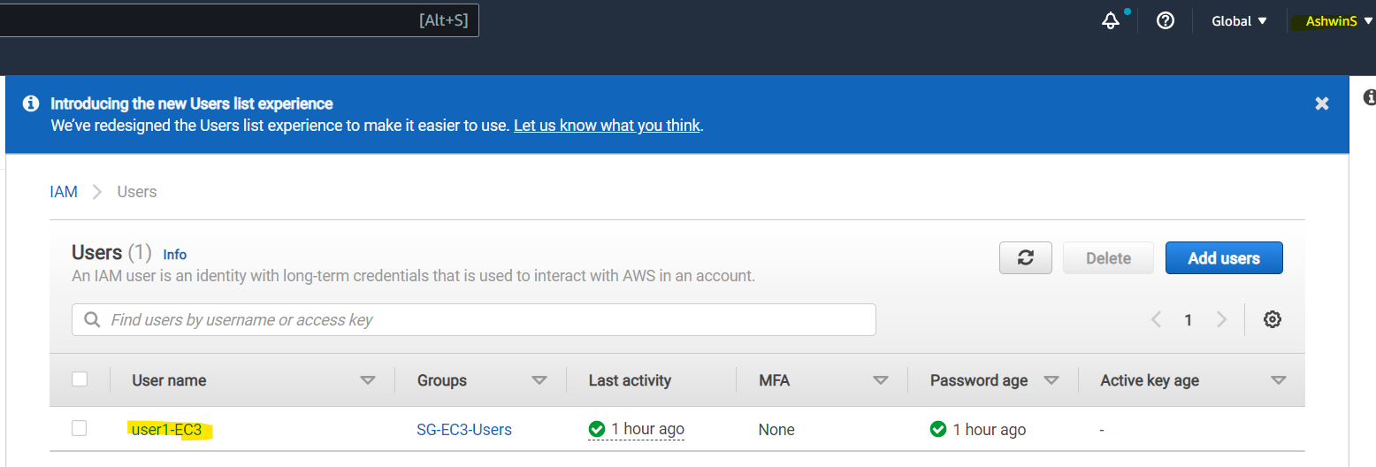

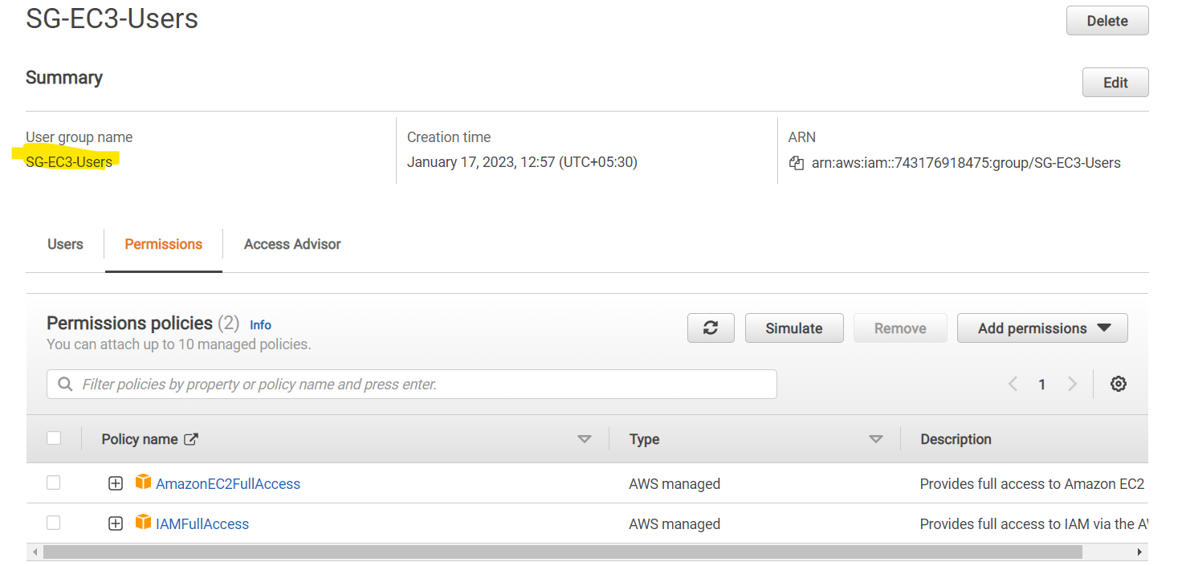

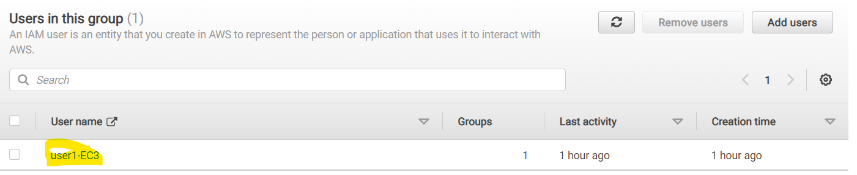

**Assignment 2** :- Hello students, in this assignment you need to prepare a developers team of avengers.

- Create 3 IAM users of avengers and assign them in developer’s groups with IAM policy.

Ans- 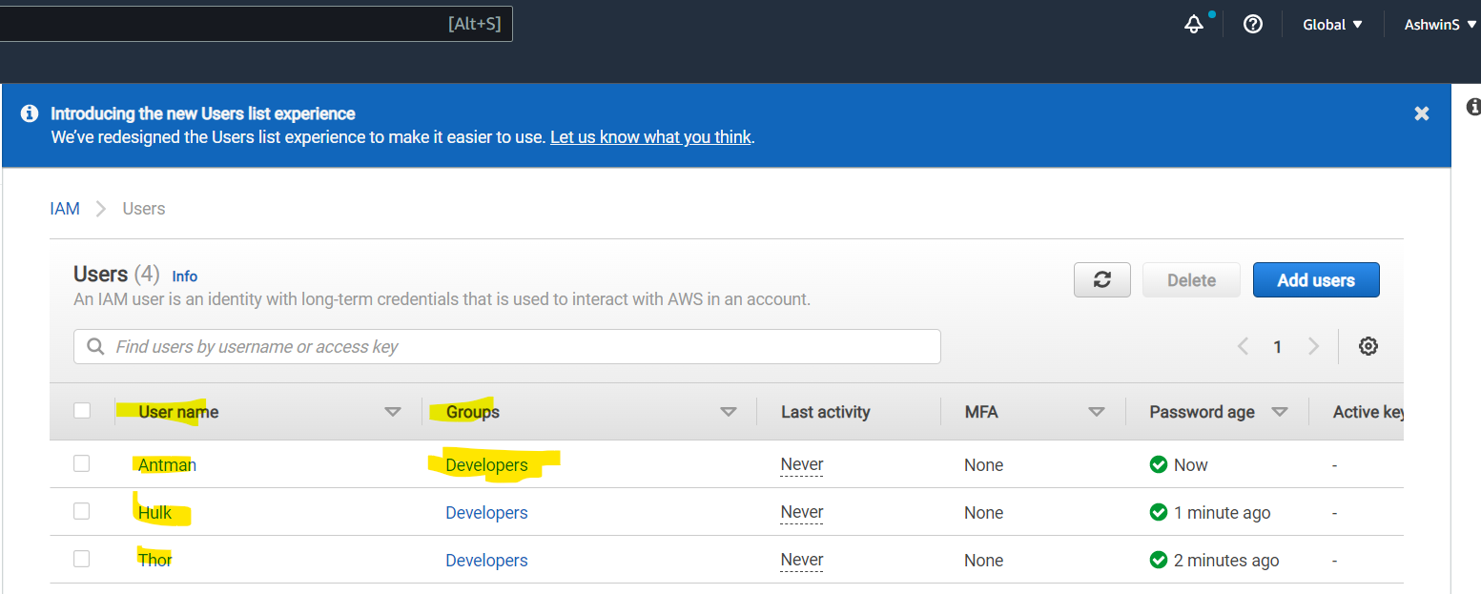

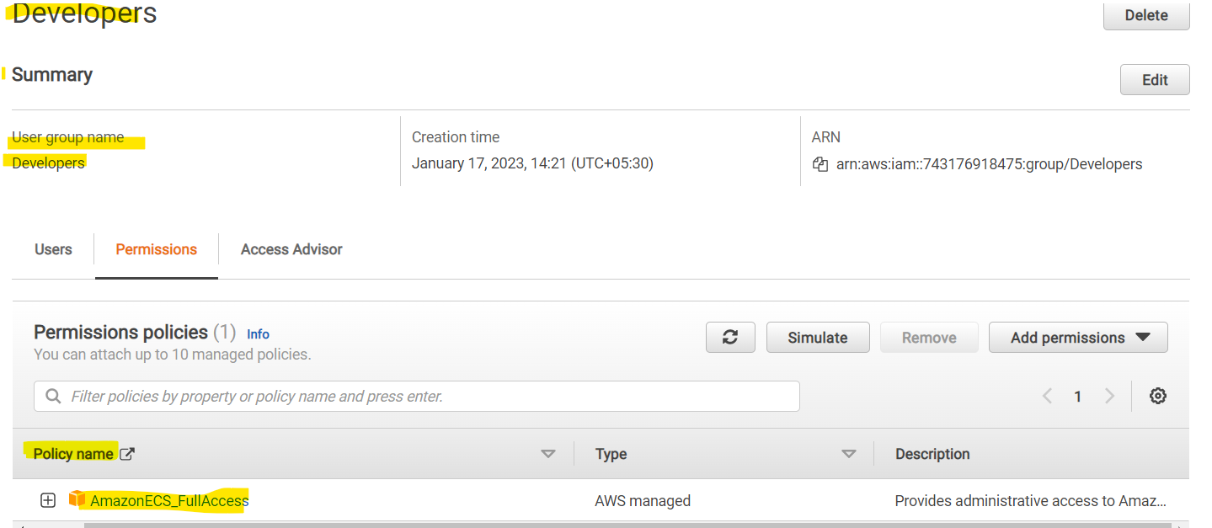

**Assignment 3** :- Define a condition in policy for expiration like

"DateGreaterThan": {"aws:CurrentTime":

"2023-04-01T00:00:00Z"},

"DateLessThan": {"aws:CurrentTime": "2023-01-01T23:59:59Z"}

Define the span of 4 months as per your wish

**Ans -** I tired but I was receiving multiple errors, not sure if below is the correct answer

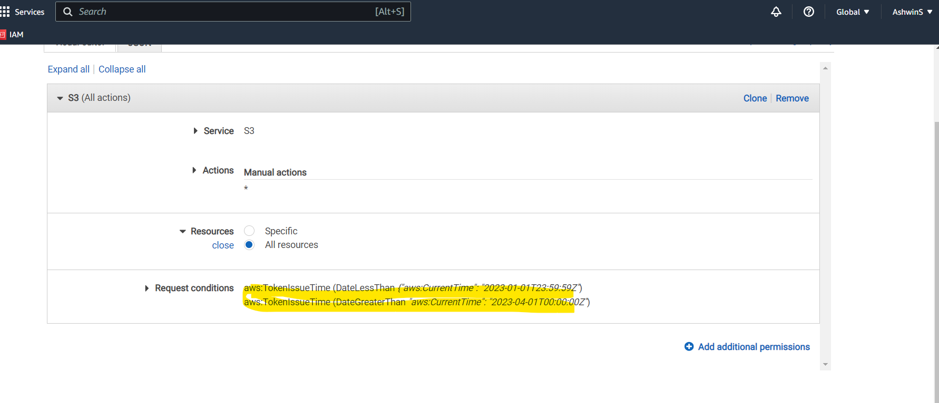

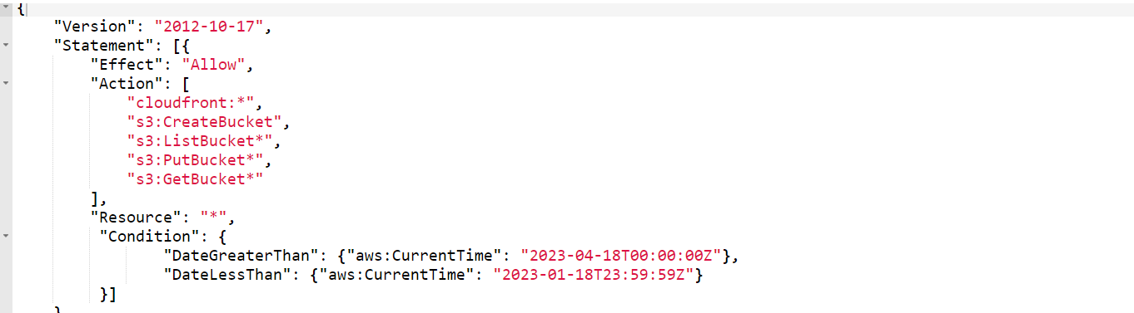

**Assignment 3** :- Prepare 15 authentic MCQ questions related to IAM.

**Ans**:- **Note**- For all questions we need to select one correct Answer

1. The IAM stands for “Internal Access Manager”

**a**. Ture **b**. False

1. IAM is ____ type of service.
2. Local **b**. Region specific **c**. Global **d.** free
3. Which of the following policy is having the highest level of access in IAM
4. AdministratorAccess **b**. AmazonEC2FullAccess **c**. AmazonInspectorFullAccess

**d.** IAMFullAccess

1. AWS does not recommends to setup the MFA for root user
2. Ture **b**. False
3. AWS allows us to create nested groups and a group can be added as a member of another group.
4. Ture **b**. False
5. The IAM user can only be member of maximum 5 groups.
6. Ture **b**. False
7. Which of the following is not the attribute of JSON format of IAM policy .
8. “ApplyTo:” **b**. “Resource:” **c**. “Action:” **d.** “Statement:”
9. In IAM it is recommended to assign permissions to group & add users to group rather than assigning polices directly to users
10. Ture **b**. False
11. Which of the following option/service is not visible for IAM users.
    1. Service Quotas **b**. Billing dashboard **c**. Security credentials **d.** Containers
12. Which of the following way is not available to access the IAM
    1. Bastion Host **b**. AWS Management Console **c**. IAM https API

**d.** AWS SDK

1. Who can restrict the permissions that are granted to the root user.
   1. AWS Control Manager **b**. Service Control Policies

**c.** MFA Manager **d.** Attribute-based Access Control

1. Which tool / service is used to monitor actions and activity of user accounts?
   1. AWS Security Hub **b**. AWS Watchgaurd **c**. Amazon Detective **d.** AWS CloudTrail
2. AWS IAM is free service and IAM users can access other AWS services without any cost.
   1. True **b**. False
3. Which is not the IAM component.
   1. Accounts **b**. Groups and Polices **c**. Users **d.** Roles
4. The “Resource:” attribute contains set of actions can be performed on a resource related to our AWS account
   1. True **b**. False

**Assignment 4** :- Launch your linux instance in IAM and update your machine.

**Ans** – I have created the LinuxVM using my IAM account.

